POCKETSMART AI

PROJECT DEMONSTRATION
Smart Budget & Recommendation Assistant

Need / Problem Statement
  - The Problem: People often struggle to manage their budgets when planning home interiors, party events, or buying matching jewelry/outfits. Searching through multiple websites manually to fit items within a specific budget is time-consuming and confusing.
  - The Solution: PocketSmart AI automates this process by using Gemini 3.5 Flash-Lite to analyze user preferences, budget constraints, and multimodal inputs (like outfit images) to recommend tailored products and budget allocations instantly.

Key Uses & Applications
  - Home Interior Budget Planner: Helps users budget and source room furniture, lighting, and appliances from platforms like IKEA and Amazon.
  - Party Budget Planner: Automatically allocates funds across catering, venue, decorations, and entertainment based on guest count and event type.
  - Jewelry & Outfit Matching Planner: Analyzes outfit images using Gemini's multimodal features to recommend matching jewelry options within the user's budget.

Technical Architecture & Stack
  - AI Model: Google Gemini 3.5 Flash-Lite - used to generate budget-based recommendations and analyze outfit images.
  - Backend: Python with FastAPI.
  - Frontend: HTML5, CSS3, JavaScript, and Jinja2 templates.
  - SDK / API: Google Gen AI SDK (google-genai) for connecting to Gemini.
  - Image Processing: Outfit images are uploaded and sent to Gemini for analysis.

Data Flow Diagram
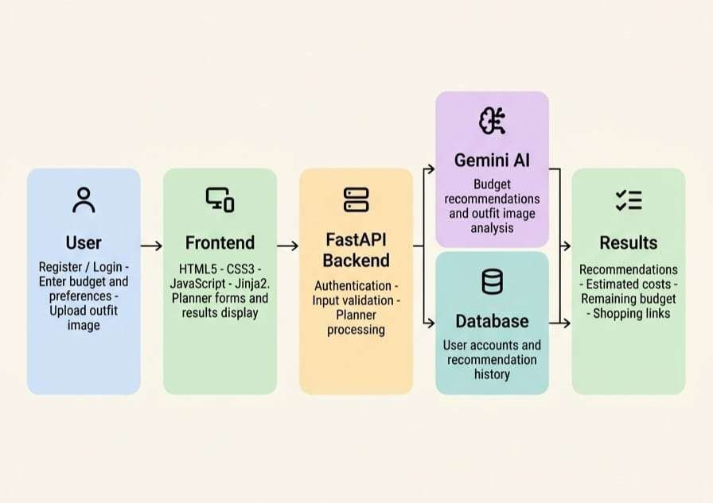

How It Works
  - Step 1: The user enters details in the Home Interior, Party, or Jewelry Planner.
  - Step 2: The frontend sends the data to the FastAPI backend.
  - Step 3: The backend validates the input and sends it to Gemini AI.
  - Step 4: For the Jewelry Planner, an optional outfit image is also sent for analysis.
  - Step 5: The recommendation is saved in the database, and shopping links are generated.
  - Step 6: The results are displayed to the user. If Gemini is unavailable, the app can provide fallback recommendations.

APPLICATION DEMONSTRATION & USER INTERFACE

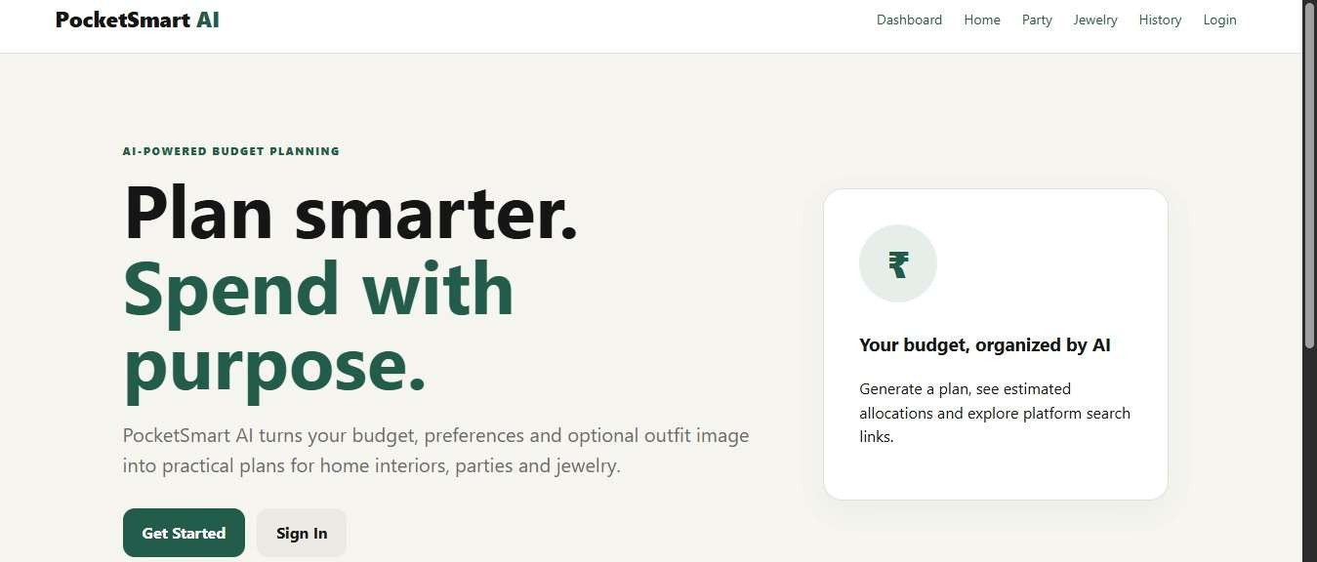
  - Landing Page

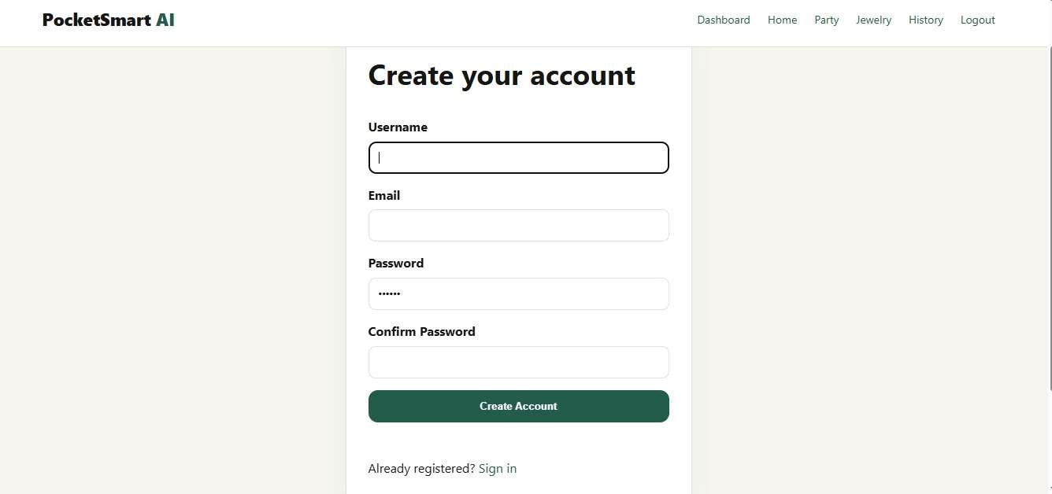
  - Account Creation Page

  - Login Page
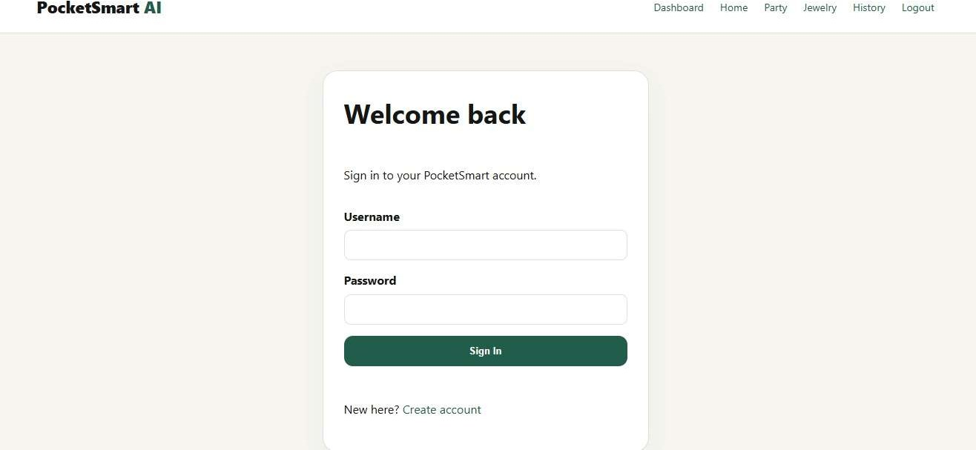
Authentication interface where returning users log in to access personalized budget dashboards.

Home Page
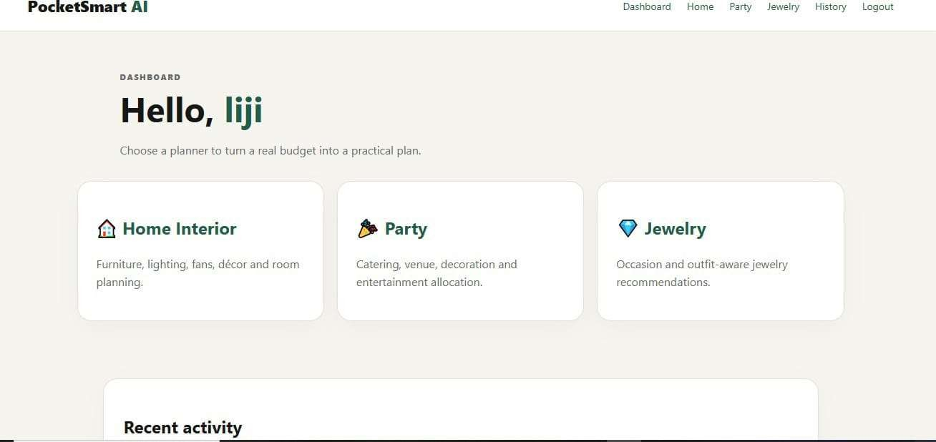
Personalized home screen displaying user welcome message, quick navigation cards for Home Interior, Party, and Jewelry planners, and recent activity overview.

Home Interior Budget Planner & Recommendation
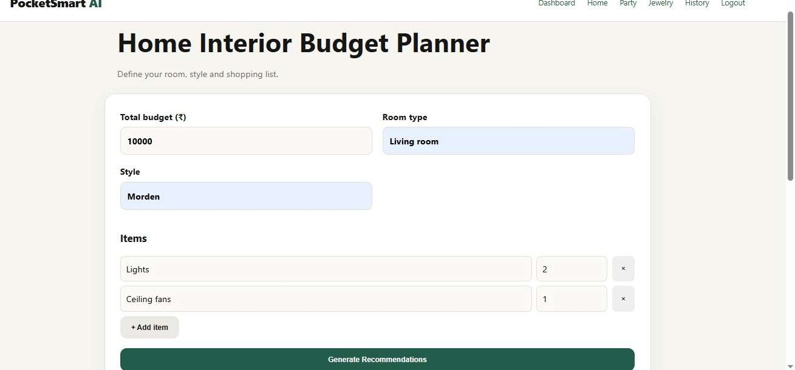
Input interface allowing budget selection (e.g., ₹10,000), room type (Living room), style preferences (Modern), and item quantities (Lights, Ceiling fans). Generates structured recommendations with itemized prices, remaining balance, and vendor purchase links (Amazon, IKEA, Flipkart).

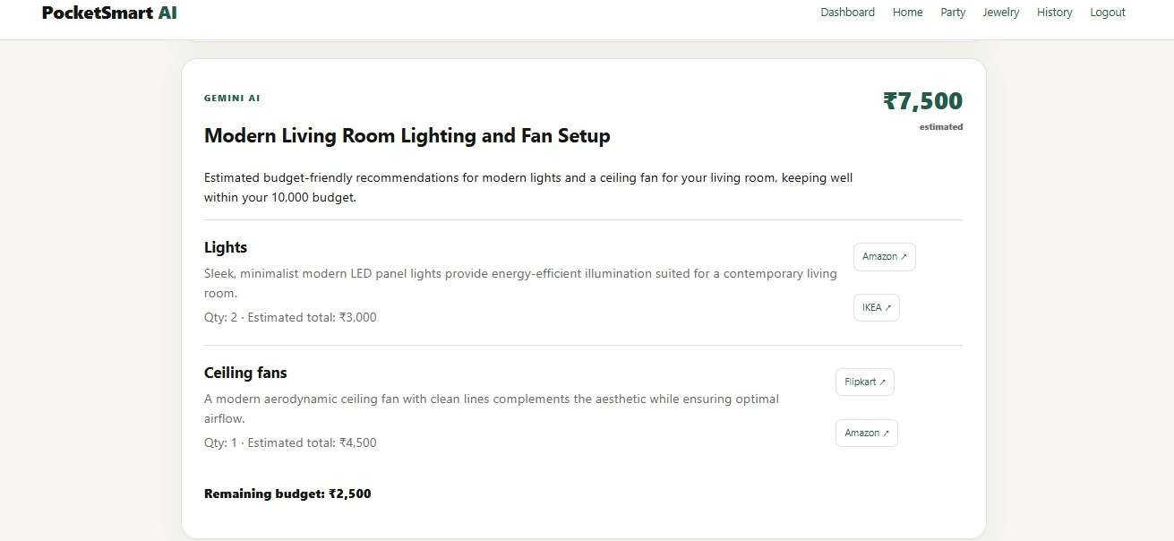
AI Recommendation

  - Party Budget Planner & Recommendation
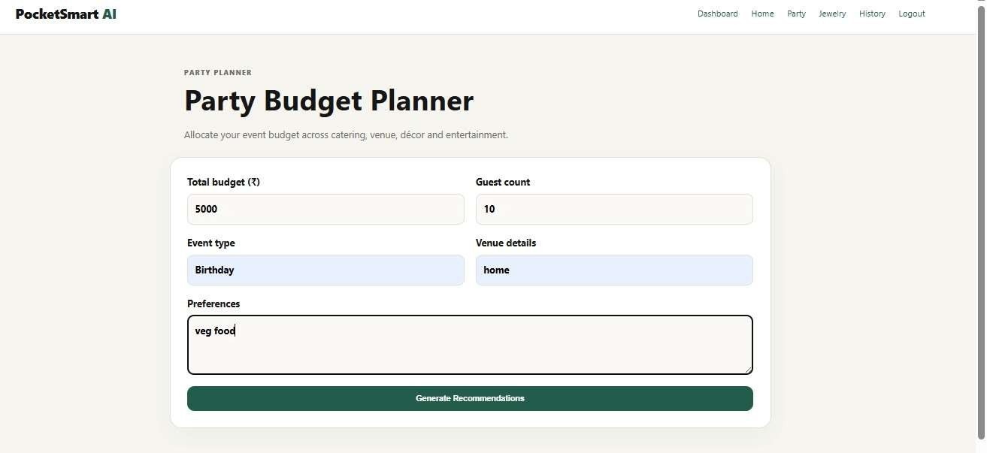
Event planner form capturing total budget (e.g., ₹5,000), event type (Birthday), preferences (Vegetarian food), guest count (10), and venue details. Displays allocated costs across Catering, Birthday Cake, Decorations, and Disposable Cutlery with Swiggy and Zomato direct order buttons.

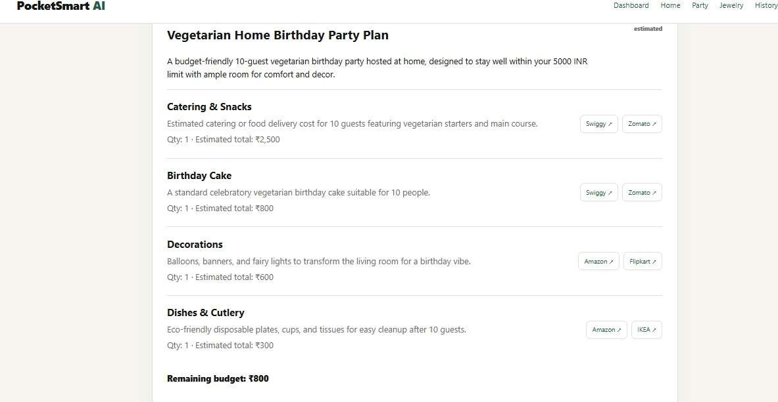
AI Recommendation

  - Jewelry Budget Planner & Recommendation
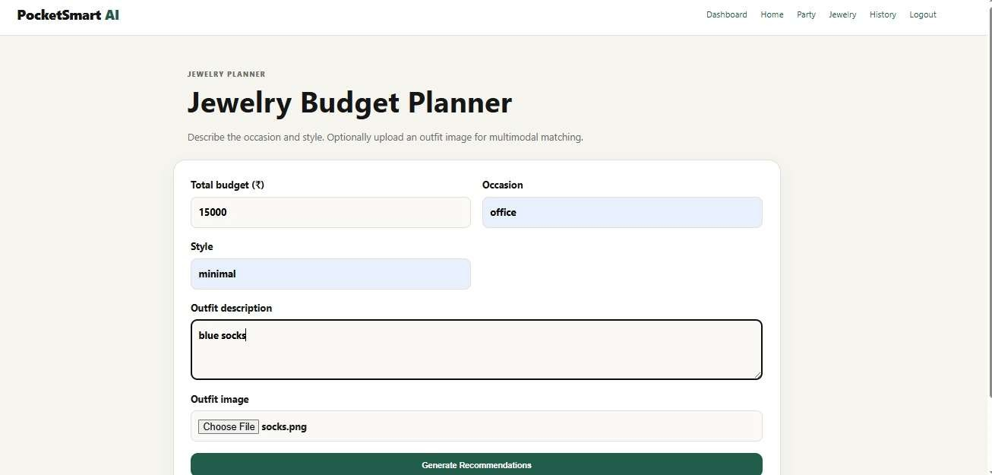
Multimodal planner taking budget constraints (e.g., ₹15,000), style, occasion (Office), outfit description, and outfit photo upload. Uses Gemini Vision to analyze outfit tone and style to suggest matching minimalist silver studs, bar necklace, and metal bracelet with purchase links.

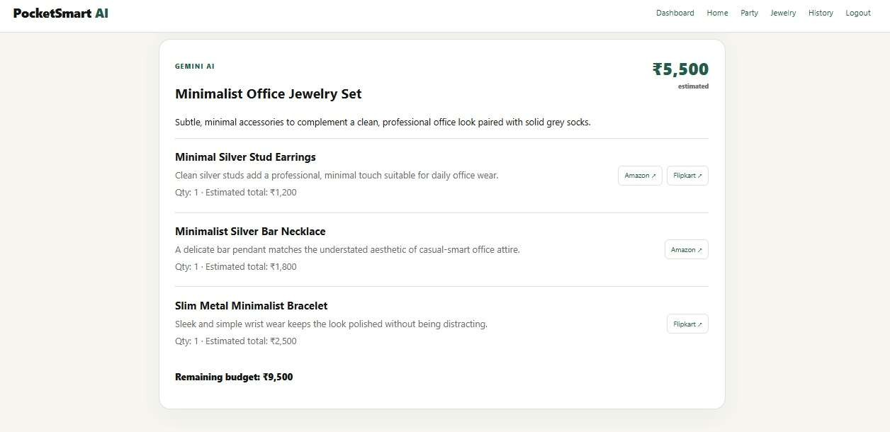
AI Recommendation

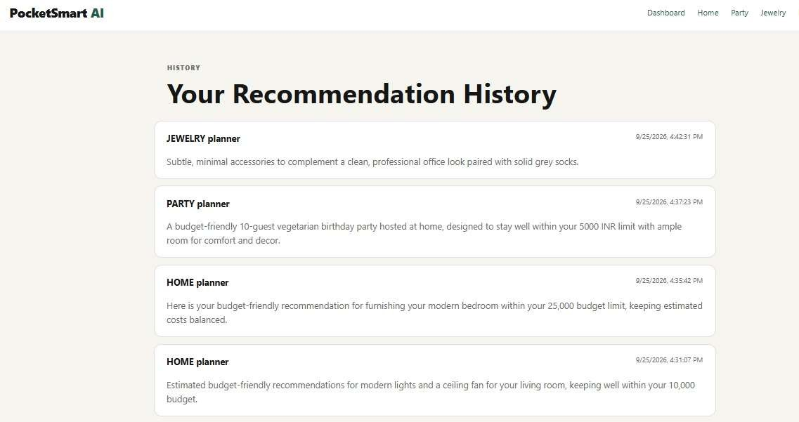
  - Recommendation History Page

Future of PocketSmart AI
In the future, PocketSmart AI can be enhanced by adding more planning categories, realtime product prices, product comparisons, and personalized recommendations based on user preferences. It could also be developed into a mobile application and integrated with more shopping platforms. These improvements would make PocketSmart AI more useful, accessible, and reliable, helping users plan their purchases efficiently while staying within their budgets.

Conclusion
PocketSmart AI is an AI-powered budget assistant developed using Python, FastAPI, Google Gemini AI, HTML5, CSS3, JavaScript, and Jinja2. It helps users plan home interiors, parties, and jewelry purchases by providing personalized recommendations, estimated costs, and shopping links within their budgets. The application also includes user authentication, recommendation history, and fallback recommendations. This project demonstrates how Generative AI can simplify everyday planning and support smarter, budget-friendly decisions.

